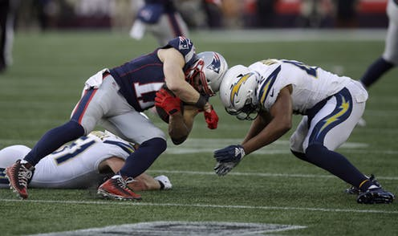
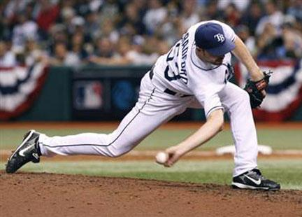

- Also known as medial epicondyle apophysitis. Causes pain and swelling inside of the elbow, can limit one's range of motion, and will limit or prevent the ability to throw a ball. Repetitive throwing can irritate and inflame the flexor/pronator tendons where they attach to the humerus bone on the inner side of the elbow.

- Can occur when the head is subject to a large impact force, resulting in a minor brain injury.

- A stretch or tear in a ligament. Ligaments are bands of fibrous tissue that connect bones to bones at joints. A strain is also a stretch or tear, but it happens in a muscle or a tendon.

- This ligament runs diagonally across in the middle of your knee and has a number of duties: It prevents the tibia from sliding out in front of the femur, as well as provides rotational stability to the knee. almost always result in a complete tear of the ligament. Work to prevent this injury by keeping your lower body strong with jump squats, lunges and landing practice.

- Injury to the tough bands of tissue (ligaments) that surround and connect the bones of the leg to the foot. The injury typically happens when you accidentally twist or turn your ankle in an awkward way. This can stretch or tear the ligaments that hold your ankle bones and joints together.

